Rebecca  Gonzalez-Bartoli |  | 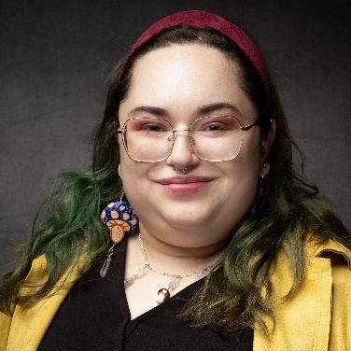

Artist Statement
I am an intuitive and expressive artist in recovery. Having experienced trauma and mental health issues since a young age, I tell stories with my art. Depicting both darkness and brightness, I display the massive joys and tragic lows of living with mental illness. I have participated in multiple exhibits and art markets since moving to Columbus. Sharing my story of recovery and inspiring others is one of the reasons I show my art. I spent June 2021-June 2022 as an artist working at Chromedge, inside Seen Studios with Fresh A.I.R. Gallery. From September 2022- December 2022 I was a vendor for seven successful art markets. I hope to continue to grow my art career in the future and use art to destigmatize those who have mental illness or substance use disorders.
 |  | Contact
 |  |  | Columbus, Ohio
 |  |  | (570)301-7464
 |  |  | mrmomolad@gmail.com
 |  |  | rgonzoarts.crevado.com

Professional Experience
Freelance Artist
Columbus, OH
September 2020-Present
Achievements
- September 2022-present spent as a vendor at multiple
art marketplaces in Columbus and the surrounding areas. Chosen as an exhibiting
Self-manages finances and inventory, interacts with artist in 2021’s Fresh A.I.R.
customers, and creates innovative ways to display and Gallery program
sell artwork.

- Participating Artist of Franklinton Friday Since Stationed at SEEN Studios,
June 2021 to June 2022. Selling handmade goods and through a program with
paintings every month while promoting artwork to a Fresh A.I.R. Gallery in June
wide audience. 21’-22’

- Continually growing a network of clients and connections, Recipient of GCAC Grant in
resulting in commissions, and selling of artwork through 2022 for individual artists
social media.

Exhibitions

2023 | Group Exhibition, Cat Show, 400 West Rich, Columbus, OH
2022 | Group Exhibition, Wild Art, Wild Goose Creative, Columbus, OH
 | Group Exhibition, 83 Gallery, 83 Gallery at Brother’s Drake, Columbus, OH
 | Group Exhibition, Art of Recovery, Fresh A.I.R. Gallery, Columbus, OH
 | Group Exhibition, Fine Arts Exhibition, Ohio State Fair, Columbus, OH.
 | Group Exhibition, This Inspired That, Open Door Studio and Gallery, Columbus, OH.
2021 | Solo Exhibition, Keep the Rage Tender, Fresh A.I.R. Gallery, Columbus, OH
 | Group Exhibition, Art of Recovery, Fresh A.I.R. Gallery, Columbus, OH
2020 | Group Exhibition, Creative Resilience, All People Arts Gallery, Columbus, OH

Publications
- “Local Gallery Features Work From Artists in Recovery From Substance Use Disorder” The Lantern, 23 Feb. 2022, https://www.thelantern.com/2022/02/local-gallery-features-work-from-artists-in-recovery-from-substance-use-disorder/

- “Weekend reading: January 21 edition” Wex, 21 Jan. 2022, https://wexarts.org/read-watch-listen/weekend-reading-january-21-editon

- “Heart and Hustle with Myken Pullins and Artists in Recovery, #136” Paulette Rees-Denis Youtube, 21 Jan. 2022, https:/youtu.be/zyizpNaokil

- “Columbus Makes Art Presents Rebecca Gonzalez-Bartoli and Her Inspirations” Columbus Underground, 26 Aug. 2021, https://www.columbusunderground.com/columbus-makes-art-presents-rebecca-gonzalez-bartoli-and-her-inspirations

